Speaker Bios for LA Day 2021

Sean Gorby is the Chair of OCA’s Government Relations Committee (GRC), a doctoral candidate at The Ohio State University, a Licensed Professional Counselor, and owner of Renaissance Counseling and Consultation. Sean has served as chair of the GRC for two years and previously served OCA as the liaison to the OCSWMFT Board. While serving as Chair of the GRC, Sean has testified in support and opposition of proposed bills on several occasions, worked with legislators and other governmental entities to construct new legislation, and conducted several presentations on leadership and legislative advocacy for OCA members. Sean and his partner, Caryn, live in Lancaster Ohio with their two young boys, Griffin and Wellington.

State Representative Sara Carruthers is currently serving her second term as state representative. She represents the 51st House District, which encompasses portions of Butler County.

Rep. Carruthers is an active community leader and philanthropist for a number of charitable causes. She has served or serves on many boards including the Hamilton Community Foundation, The Michael Feinstein Great American SongBook Foundation and Fort Hamilton Hospital. She is a member of P.E.O., Hamilton Garden Club, Arronoff Center for the Arts, Pyramid Hill Sculpture Park, Fitton Center, Christ Church Glendale, Delta Zeta Sorority and the Butler County (Ohio) Republican Party.

In addition to her extensive community involvement, she also has a media background and was a White House Press assistant during the Ronald Reagan and George H. W. Bush administrations.

She serves as the Chair of the House Behavioral Health & Recovery Supports Committee – a new committee created this General Assembly, which emphasizes the renewed focus the Ohio House is willing to give on mental health and related issues.

Ryan Pendleton is the CFO/Treasurer of Akron Public Schools where he oversees a budget of more than $500 million in public funds. Ryan is dedicated to serving the community, in particular the students of Akron Public Schools. He is very active in state and federal issues concerning education and the potential impact on the students of Ohio.

During his career, Ryan has received multiple awards including the Chuck Gossett Legislative Award, the Regional Distinguished Service Award and the statewide Virginia Ramsey Service Award from Ohio Association of School Business Officials (OASBO). Ryan is a Leadership Akron Class 32 graduate and serves on the board of Akron Roundtable and previously on the board of the Barberton Community Foundation. Prior to working at Akron Public Schools, Ryan was the Treasurer/CFO of Barberton City Schools for nine years and worked previously as a financial advisor.

Ryan has been one of the key members of the school funding workgroup that has been working in earnest to craft the current HB 1 funding formula over the last few years.

State Senator Teresa Fedor represents the 11th Senate District, which includes Toledo and other parts of Lucas County. She previously served in the Senate from 2002-2010, following eight years as the Ohio Representative for the 45th and 47th House Districts. Throughout her legislative career, Senator Fedor has championed responsive and responsible government. She brings with her an accomplished body of legislative work focused predominantly on education, health care, and human trafficking where she is considered the state’s preeminent legislative voice in the fight to combat it.

Senator Fedor also currently sits on the Ohio Arts Council. She is a member of the American Legion, the National Conference of State Legislatures Criminal Justice Committee, and the National Conference of State Legislatures Education Committee. A proud veteran of the U.S. Air Force and Ohio Air National Guard, Senator Fedor spent 18 years in the classroom at Toledo Public Schools before first pursuing elected office in 2000.

She is currently the Ranking Member on the Senate Primary & Secondary Education Committee, and has helped lead legislative efforts to provide flexibility for schools in light of COVID-19.

State Rep. Jessica Miranda has a passion for education policy and greater economic opportunity for her constituents in the 28th House District, which includes a portion of Hamilton County. A graduate of Talawanda High School, she is a proud product of public schools.

As a small business owner providing insurance and tax services, Jessica has won awards for her Licensed Property & Casualty Insurance Brokerage practice and holds numerous IRS certifications. She is also the past president of the Winton Woods City School Board, where she worked to improve standards for attendance, curriculum and fiscal responsibility. Rep. Miranda was proud to introduce legislation on common-sense gun storage last session and is supportive of fair school funding.

The Representative was the sponsor of OSCA’s priority bill last General Assembly, HB 367, to require ODE to create a model job description for school counselors and designate a specific liaison for school counselors within ODE. This bill would promote better use of school counselors’ time, improve role clarity and empower school counselors to advocate for their real value in a school setting. Rep. Miranda is planning to reintroduce the bill soon for OSCA and we are grateful to her for her work on this issue.

Ryan Pickut graduated from the University of Toledo in 2008 with a MA in community counseling. He worked for eight years at a community mental health agency with the focus on children, adolescent, and family counseling. At that agency, he also served as the crisis team leader for one year. He earned his school counseling credentials in 2012, and then served one year as a consultant to Toledo Public Schools with regards to their critical incident response planning. He received his LPCC in 2012 and then his LPCC-S in 2013. Currently he serves as Clinical Director of Adult Residential Services at A Renewed Mind, a behavioral healthcare agency in Toledo. In that position, he oversees the daily operations and program development for residential programs. The current NWOCA president, he also serves on the Lucas County Mental Health and Addiction Services Disaster Response Team and is professional member of ACA, OCA, and OACES. His Board term is up this October.

Brian Carnahan is the Executive Director of the Ohio Counselor, Social Worker & Marriage and Family Therapist Board, where he is responsible for the leadership and administration of the Board’s operations. Brian joined the Board in August 2014. Prior to joining the CSWMFT Board, he was Director of the Ohio Housing Finance Agency's Office of Program Compliance.

Brian has served on the Association of Social Work Boards bylaws committee and is currently actively involved with other industry association committees such as the FARB Finance Committee. He represents Ohio boards and commissions on the eLicense Leadership/Advisory Panel and serves as the facilitator of a regular meeting of boards and commissions. He has published dozens of articles on licensure topics, regulatory affairs, and housing and community development in publications such as Social Work Today, Counseling Today (online), The New Social Worker, FARB Focus, among others.

Brian serves on the Board of Homes on the Hill, a community development corporation serving Columbus’ Hilltop neighborhood as well as other neighborhoods in western Franklin County.

Government Advantage Group

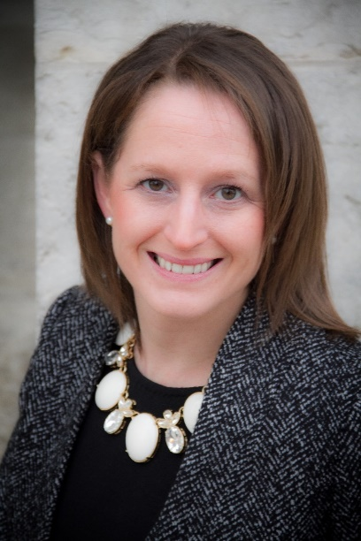
Amanda Sines, Partner at GAG has been involved in state government relations in Columbus, Ohio for over 13 years. Amanda began her career in state government by working as a page in both the Ohio House of Representatives and Ohio Senate while getting her degree in political science at The Ohio State University. After college, she went to work as a legislative aide to a State Senator, before moving to the private sector in 2004 to work in lobbying. Amanda began her lobbying career working for one of the first female owned independent lobbying firms (Towner Policy Group) where she represented a variety of client interests before the state legislature and Ohio regulatory agencies. In 2015, Ms. Towner retired and Amanda started her own business, Capitol Action Team, with the clients she had been representing with Ms. Towner. In 2016, Amanda became a partner of Government Advantage Group. Amanda currently serves on the Board of Directors for the Ohio Lobbying Association, the planning committee for the Ohio YMCA Youth in Government program and is an active member of the Ohio Woman in Government organization. Amanda is also an Ohio Lobbying Association Certified Lobbyist.
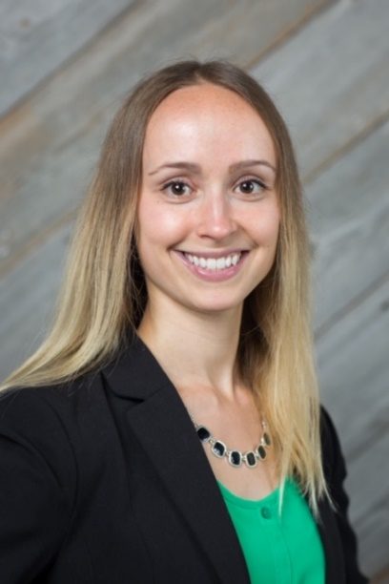
Julia Wynn, Director of Government Affairs
Julia has spent her entire Ohio career in and around state government and politics. A 2015 alumna of the competitive Statehouse Legislative Service Commission Fellowship Program, she came to Columbus from her hometown outside of DC, where she held a number of legislative and policy positions in the nation’s capital before starting the Fellowship. She served as a Legislative Aide in the Ohio House of Representatives for a little over two years, gaining critical state budget experience as a policy staffer for a finance subcommittee. During her years in the House, Julia also became deeply involved in Ohio Women in Government. She currently serves at the group’s Membership Chair, a position she was reelected to in 2018. She joined Government Advantage in early 2019 fresh off the campaign trail, where she managed finance operations for a statewide candidate. Julia graduated Summa Cum Laude and Phi Beta Kappa from Denison University with a BA in Sociology and Communication.

