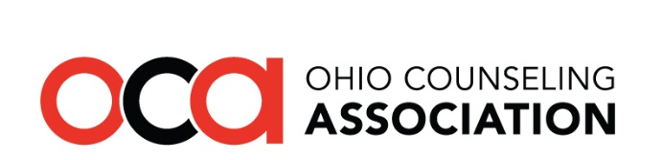
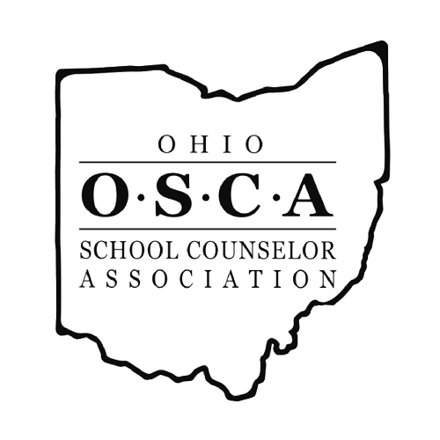

Legislative Advocacy Day
Tuesday April 13th 2021 ● Virtual Conference

AGENDA

9:00 AM Welcome
- Jason McGlothlin, OCA President
- Sara Hoffman, OSCA President

Introduction & Orientation
- Sean Gorby, OCA Government Relations Chair
- Nichole Miller, OSCA Government Relations Chair
- Amanda Sines & Julia Wynn, Lobbyists, Government Advantage Group

OCA & OSCA Political Action Committees Introduction

10:00 AM TBD

10:30 AM Ohio House Priorities in Behavioral Health
- State Rep. Sara Carruthers, Chair of New House Behavioral Health & Recovery Supports Committee

11:00 AM Lunch Break
 | OSCA Breakout | OCA Breakout
11:30 AM  12:00 PM  12:30 PM | The New School Funding Formula  - Ryan Pendleton, CFO of Akron City Schools  Policies Providing Flexibility for Schools in Light of COVID-19  - State Sen. Teresa Fedor (Toledo)  A Model Job Description for School Counselors  - State Rep. Jessica Miranda (Forest Park) | The Interstate Counseling Compact – A Panel Discussion with:  - Ryan Pickut (CSWMFT Board)  - Sean Gorby (OCA GR Chair)  - Amanda Sines (OCA Lobbyist)
1:00 PM Afternoon Snack Break

1:30 PM OCSWMFT Board Presentation

2:30 PM LAD Wrap-Up

3:00 PM End of Day

This program content has been approved for four CE hours via OCSWMFT provider #RCS031407.
Be sure to sign in and complete the session survey at the end of the day. You will receive your
CE certificate via email after the event.

