Attendance Reports in Zoom
Ohio Counseling Association (OCA) – Professional Development Committee

Zoom can show you reports about your meetings and your attendees. Attendee and participation information for your meetings can be retrieved for up to one year after the date of that particular meeting. The meeting also needed to have lasted at least 30 minutes.

This step by step guide will help you determine 1) if your Zoom account has the ability to provide these reports, 2) how to find the report for your event, and 3) what you need to do with this information to fulfill the post-event activities requirements with the OCA Professional Development Committee.

Step 1 – Find out what type of Zoom account you have.

Pro, Business, Enterprise, Education, or API Zoom accounts have the ability to run User reports for the attendance information. If you don’t know what type of account you have, you will need to find this out.
Sign into the Zoom account. Click on the “Account Management” in the left-hand menu.

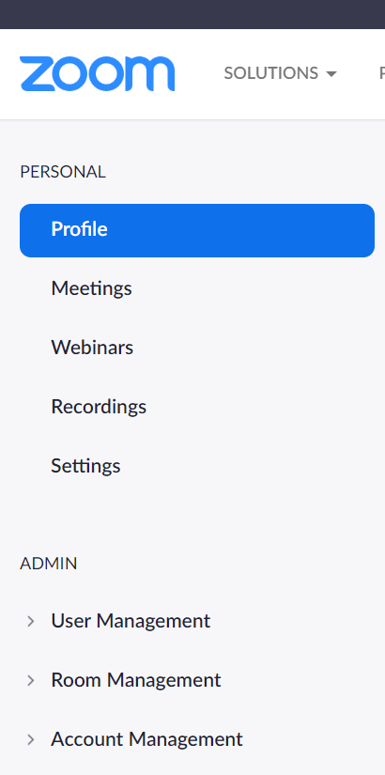

Click on “Account Profile”

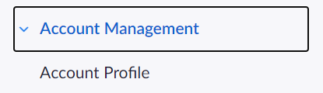

Look at the “Account Type”. If it says Pro, Business, Enterprise, Education, or API you have an account that will run this type of report for you.

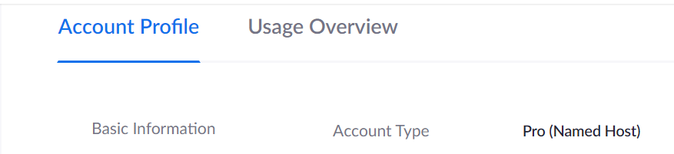

Step 2 – Open the Reports page

Under Account Management, click on Reports. This will open the Reports page for you to find your information.

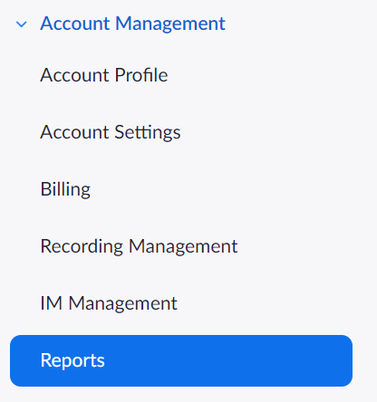

Step 3 – Open the Active Hosts reports page

Click on the Active Hosts option on the Usage Reports page (loads by default when you click on Reports).

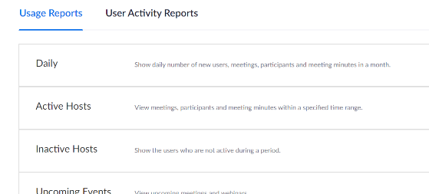

Step 4 – Set the date range to find your meeting

You can change and set the date range to search through your meetings. This is a very helpful feature if you are hosting several different types of meetings or if you host a lot of meetings. It will take at least 30 minutes after the conclusion of a meeting for the attendance information to be ready in the system. Once you have the date range set, click Search.

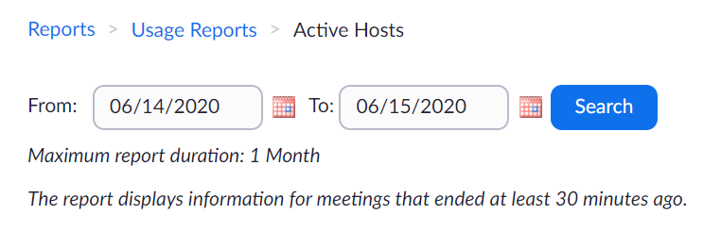

Step 5 – Find the Participants column

After you click Search, you will be presented with a list of all your meetings in the date range. There are several columns of information for each meeting. Depending on the size of your screen, you may need to scroll down to the bottom of the list and then scroll over to the right in order to see all of the columns. Near the far right, you will see a column named Participants. In that column you will see numbers in blue.

Step 6 – Check the Participants information

In the Participants column, you will see the number of your participants from each meeting in blue.

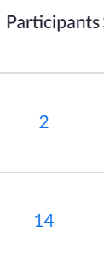
Click on the blue number and it will open a new window with additional information.

Now you can see who attended the meeting, what time they joined and left the meeting, and the duration of their participation in the meeting. You can compare this to your registration list to confirm that registrants attended the entire meeting for their CE credit.

Step 7 – Send attendee information to the OCA Professional Development Committee Chair

First, export the attendee report into a Word, PDF or Excel document by clicking on the blue Export button on the upper right-hand side of the window. Save the created document.

Create a second document that lists: Full name of your attendees, full license number (letter and all numbers), and if they attended the full meeting to get full CE credit. This can be done by putting a check mark or X next to their name. IF someone did not attend at all or left too early for CE credit, note this so that only the appropriate individuals get full CE credit.

Email BOTH of these documents to the Chair of the OCA Professional Development Committee. The exported list provides the proof of attendance and the second document provides all the necessary information to award the CE’s.

