Ohio Counseling Association
Spring Conference
April 22-23, 2022

The OCA Spring Conference brings together Counselors from across Ohio to teach, learn, and collaborate on a variety of topics. Join us to work on your general, ethics, and supervision credits for licensure.

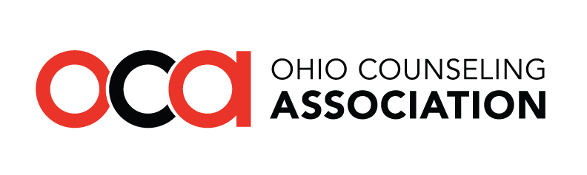
All programming is approved for CSWMFT CE Credit for Counselors, Social Workers, MFTs, and some Chemical Dependency Professionals

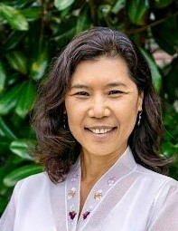
Dear Attendees,

I am delighted to welcome all of you to the two-day virtual
Ohio Counseling Association Spring Conference 2022!

We are excited to introduce the incredible presenters with a variety
of session topics. Special thanks to the input from OCA members,
which helped identify the Keynote Speaker Panel.

We are grateful for your collaboration!

We understand your time is valuable and appreciate you spending it with us. Our conference was carefully planned to create an opportunity for you to hear from colleagues. These exchanges of experience and knowledge help us to be effective counselors, supervisors, and educators.

I am deeply grateful to the OCA Professional Development Committee, the Executive Director, and the Conference Committee as well as the Virtual Volunteers for how they have brought us together.

I hope the conference energizes you with new ideas and helps connections with colleagues.

We also look forward to your completed evaluation to let us know how we can strengthen the conference.

Warm Regards,
DoHee Kim-Appel, Ph.D., LPCC-S
2021-2022 OCA President

Thanks to the Ohio Mental Health and Addiction Services for their sponsorship
mha.ohio.gov/GetHelpEarly
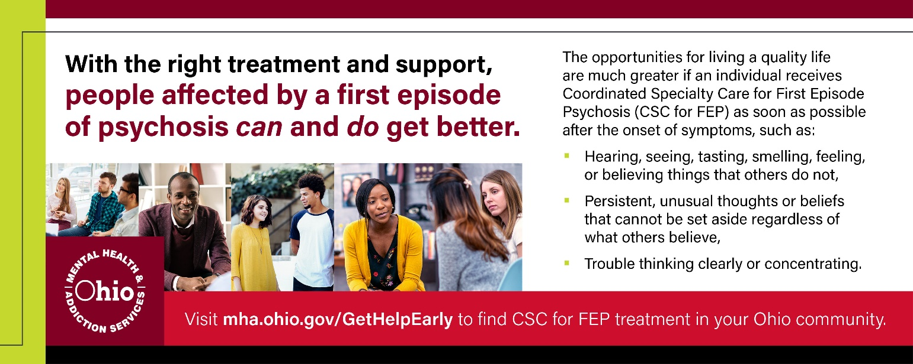

Keynote Panel: The Importance of Comprehensive Cultural Competence
Friday, April 22 from 9:00 a.m. to 10:00 a.m.
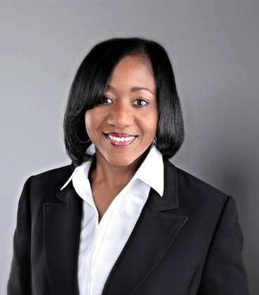  Moderator | Sherdene Simpson, Ph.D, LPCC-S, LMFT, CHT is a Visiting Assistant Professor of Counselor Education at Cleveland State University. She is a Licensed Professional Clinical Counselor, with Supervisory designation (LPCC-S), Licensed Marriage and Family Therapist (LMFT), Certified Clinical Hypnotherapist (CHT), and Certified in Grief Recovery Methods with experience in community and private practice settings. Her clinical interest include incorporating systemic therapy to individuals, couples, and families. Her research interest include systemic treatment, marriage and family therapy, clinical supervision, multiculturally informed clinical supervision, and isomorphism in clinical supervision. She is a certified trainer for PREPARE/ENRICH Inventory and is currently completing training for the Gottman Institute Certification program.
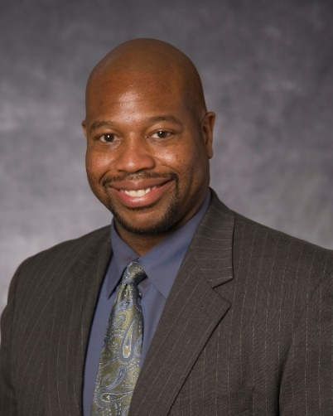 | Aaron Ellington, Ph.D., LPCC-S, LICDC-CS is one of the founders and owners of Behavioral Health Services of Greater Cleveland. His doctorate and master’s degree are in counseling psychology from Cleveland State University and University of Wisconsin at Madison respectively. He is licensed in the state of Ohio in Psychology, Counseling, and Chemical Dependency. He is a Diplomate in Cognitive Behavioral Therapy from The Academy of Cognitive Therapy. Nevertheless, he is well trained in Dialectical Behavioral Therapy and Motivational Interviewing as well. He is well versed in running groups, individual counseling, assessments (psychosocial, chemical dependency, and some psychological testing), training seminars, research, crisis intervention, and case management.
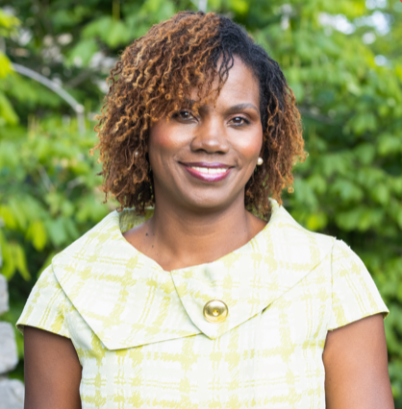 | Shantel Thomas, Ph. D. PCC-S, LSW is President and CEO of A Sound Mind Counseling Service, LLC. She received her B.A., M. Ed. from the University of Toledo where she attended on a full athletic scholarship and had a stellar career as a sprinter, traveling the world competing and receiving various honors, including MAC Athlete of the Year and NCAA Woman of the Year for Ohio. Her doctorate is from Kent State University. Thomas was inducted into the University of Toledo’s Hall of Fame and selected as one of Cincinnati’s Leading Women. She was a Health Care Hero and Athena Awards finalist in 2006. She was also honored in Who’s Who of Black Cincinnati in 2009 and 2007. She is a member of Alpha Kappa Alpha Sorority, Inc. and a life member of the Ohio Counseling Association.

Thank you for attending, please fill out an evaluation form for each session you attend
https://www.ohiocounseling.org/resources/Documents/SC-Eval.docx

PROGRAM SCHEDULE

Friday
9:00 am – 10:00 am

TITLE | PRESENTERS | DAY/TIME/CEs
Keynote Panel:  Importance of Comprehensive Cultural Competence | Sherdene Simpson  Aaron Ellington  Shantel Thomas | FRIDAY  9-10am  1 General CE
10:30 am - 11:30 am

Body Image and Eating Patterns in Older Adults | Anna Ellenson  Michelle Sammons-Ingrisano | FRIDAY  10:30-11:30am  1 General CE
Ethical Risk Reduction | Megan Mahon  Carrie VanMeter  Tara Hill | FRIDAY  10:30 – 11:30pm  1 Ethics CE
Gender-Sensitive Counseling with Male Clients | Daniel Bates | FRIDAY  10:30 – 11:30am  1 General CE
12:00 pm - 1:00 pm

The Ohio Counseling Association Insurance Advocacy Initiative  Anyone in clinical practice has likely run into issues with insurance coverage for clients. The OCA Insurance Advocacy Committee has been formed to assist our membership in resolving problems that stand in the way of reimbursement, providing effective treatment, and communicating with insurance companies. Any and all are welcome to attend this meeting to hear more about our committee and to share their experiences. | Martha Flemming, Adrianne Johnson, Lee Roppel, Mike Desposito, & Kailey Bradley-Thomas | FRIDAY  12:00 – 1:00pm  No CE credit  ZOOM LINK
The OCA Graduate Student Panel  The OCA Graduate Student Committee is proud to invite all counseling graduate students from the state of Ohio to attend our 4th Graduate Student Panel. This panel will consist of graduate students and members of the OCA Graduate Student Committee as well as other students who advocate for the professional development of graduate students. The purpose of the panel is for counseling graduate students to freely ask questions about graduate school, counseling licensure, clinical practice, clinical supervision, and more... within a non-judgmental space.  Furthermore, the OCA Graduate Student Committee would like to learn from students directly what OCA and our committee can do for them. The professional development of graduate students is our committee’s highest priority. Please come with any questions and/or suggestions of what you would like to see from OCA and us in the future! | Natalie Ricciutti, Fawn Gordon, & Samantha Gress | FRIDAY  12:00 – 1:00pm  No CE credit  ZOOM LINK
Educate & Advocate with SAIGEO: Ohio House Bill (H.B.) 454  Join members of the Executive Board of the Society for Sexual, Affectional, Intersex, and Gender Expansive Identities of Ohio (SAIGEO; formerly ALGBTICO) to learn about Ohio H.B. 454, known as the “Save Adolescents from Experimentation” (SAFE) Act, which seeks to ban gender-affirming healthcare for trans and gender expansive youth across the State of Ohio. We will discuss what is in H.B. 454, we will provide corrective education on the many misrepresentations within H.B. 454 about trans and gender expansive youth and gender-affirming healthcare, we will elaborate on how the work of counselors and the lives of trans and gender expansive youth would be adversely impacted if H.B. 454 were signed into law, we will discuss the steps that SAIGEO, OCA, and other allied organizations have taken against H.B. 454, and we will discuss what you can do to advocate against this potentially devastating and deadly piece of legislation. | Chase Morgan-Swaney | FRIDAY  12:00 – 1:00pm  No CE credit  ZOOM LINK
1:00 pm - 2:00 pm

Counselors as Clients: An Exploration of Personal Counseling for Counselors and Counseling Students | Brad Imhoff  Robert Switala  Jeff Mazzone | FRIDAY  1:00 – 2:00pm  1 General CE
Earth and Sky, Woods and Fields: Incorporating nature when working with children, youth, and families. | Debbie Sturm | FRIDAY  1:00 – 2:00pm  1 General CE
Ethical and Legal Considerations for Telehealth in Ohio | Stephanie Maccombs-Hunter | FRIDAY  1:00 – 2:00pm  1 Ethics CE
2:30 pm - 3:30 pm
2:30 pm- 4:30pm (2 Ethics CEs)

Demystifying Insurance: A Comprehensive Guide for Clinicians | Adrianne Johnson  Meredith Craig  Jana Jarrett | FRIDAY  2:30 – 3:30pm  1 General CE
Taking the “Dis” Out of Disability: Exploring advocacy and counseling for those who are differently abled | Staci Hayes  Kathy Caputo | FRIDAY  2:30 – 3:30pm  1 General CE
Legal and Ethical Issues in Counseling, Social Work, and Marriage and Family Therapy 2022 | Andy Miller | FRIDAY  2:30 – 4:30pm  2 Ethics CEs
4:00 pm - 5:00 pm

Trauma-Informed Counselors of Ohio: Introduction to the Ohio Association for Resiliency and Trauma Counseling Resiliency Initiatives | Alicia Hall  Tahani Dari  Jenny Cureton  Kalesha Jenkins | FRIDAY  4:00 – 5:00pm  1 General CE
The Myth of Balance | Patricia Stewart-Hopkins | FRIDAY  4:00-5:00pm  1 Supervision CE
The Intersection of Complicated Grief and COVID-19: Enfranchising Forgotten Grievers | Kailey Bradley | FRIDAY  4:00 – 5:00pm  1 General CE
5:30 pm - 6:30 pm

ACT’s Six Core Processes: Exploring the key aspects of Acceptance and Commitment Therapy | Trey Gehring | FRIDAY  5:30 – 6:30pm  1 General CE
Race, Trauma & Mental Health, Oh My! | Carmella Hill | FRIDAY  5:30 – 6:30pm  1 Ethics CE
Building the Therapeutic Alliance via Teleconferencing since the Covid-19 Pandemic: Counseling Skills | Genice Williams-Rivers | FRIDAY  5:30 – 6:30pm  1 General CE

Saturday

10:00 am -11:00 am

Practical Supervision Strategies for Supervisees Who Work with Refugees | Kübra Civan  Yegan Pillay | SATURDAY  10:00 – 11:00am  1 Supervision CE
Incorporating Motivational Interviewing as a Group Leadership Orientation | Andrew Herbell  Annaleise Fisher  Kimberlee Barrella | SATURDAY  10:00 – 11:00am  1 General CE
Virtually Counseling: What counselors need to know the Metaverse and connecting in virtual spaces | Staci Hayes  James Hoag | SATURDAY  10:00 – 11:00am  1 General CE
11:30 am -12:30 pm

Using Psychodrama Techniques in Supervision with Counselors and Counselor-Trainees | Amanda Cole | SATURDAY  11:30 – 12:30pm  1 Supervision CE
Language Matters: The Why and How-To of LGBTGEQIAP+ Affirming Language | Jared Rose  Hannah Rowe | SATURDAY  11:30 – 12:30pm  1 General CE
Under Pressure: How self-compassion-based group work can address performance anxiety concerns among college students | Amanda Shuluga  Sean McKinney  Kelly Smith | SATURDAY  11:30 – 12:30pm  1 General CE
1:00 pm -2:00 pm

Working with Suicidal Clients: Policy, Procedures, and Practices for Avoiding Malpractice | Jason McGlothlin | SATURDAY  1:00 – 2:00pm  1 Ethics CE
Equine Assisted Psychotherapy for Combat Veterans with Post Traumatic Stress Disorder: A Literature Review | Cherry Nelson | SATURDAY  1:00 – 2:00pm  1 General CE
Trauma Informed Communication During Crisis De-escalation | Patricia Stewart-Hopkins | SATURDAY  1:00 – 2:00pm  1 General CE
2:30 pm - 3:30 pm

Substance Use Disorder Treatment for the Family | Martina Moore | SATURDAY  2:30 – 3:30pm  1 General CE
Counseling Termination: Tools for Ethically Sound and Relationally Meaningful Closure | Christina Schnyders  Kristin Bruns | SATURDAY  2:30 – 3:30pm  1 Ethics CE
Understanding the Double Empathy Problem Concept to Create a Cohesive Classroom for All Students | Susan Fox | SATURDAY  2:30 – 3:30pm  1 General CE
4:00 pm - 5:00 pm

Can everyone hear me? Considerations for Cross-Cultural Group Counseling in a Digital World | Christina Woloch  Natalie Thornberry  Christin Fontes | SATURDAY  4:00 – 5:00pm  1 Ethics CE
Absent/Low Sexual Desire in Women: Addressing the Problem from a Systemic Point of View | Yvonne Judge | SATURDAY  4:00 – 5:00pm  1 General CE

Thanks to our Spring Conference Sponsor:
mha.ohio.gov/GetHelpEarly
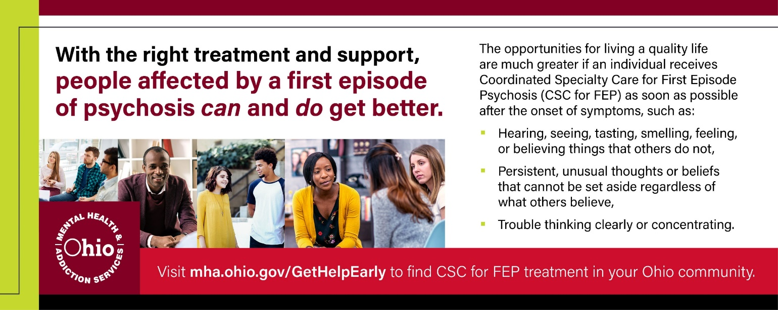

PROGRAM SESSION DETAIL – IN ORDER OF PRESENTATION

FRIDAY, April 22, 2022 Presentation Detail
9:00 a.m. – 10:00 a.m.

Importance of Comprehensive Cultural Competence (1.0 General CEs) – Sherdene Simpson, Ph.D, LPCC-S, LMFT, CHT (Moderator) of Cleveland State; Aaron Ellington, PhD, LPCC-S, LICDC-CS of University Hospitals and Behavioral Health Services of Greater Cleveland; and Shantel Thomas, Ph.D. LPCC-S, LSW of A Sound Mind Counseling Service and Center For Healing The Hurt

Diversity, Equity, and Inclusion (DE & I) are essential to being a culturally competent counselor. To be a culturally competent counselor requires more than just empathy and understanding of individuals who are unlike yourself. It's essential to understand how the individual's environment and everyday interactions affect what the client brings into session.

Also, it is necessary to acknowledge that we all have some unconscious biases and learn to manage them. Insight into our own bias can help counselors understand the impact of their engagement, grouping, and treatment of coworkers and clients on a daily basis. Therefore counselors must first be culturally alert, understand Diversity, Equity, and inclusion, and implement comprehensive cultural competence. This will be strengthening ways to develop a thriving culturally intentional practice in various settings, including private practice and beyond. This presentation will review the need to assess the role culture plays in a client's daily experiences and what they bring to the session. Understanding these roles will help the clinician build rapport quicker, be more empathetic, and genuinely provide appropriate skills and resources that will be helpful to the counseling process.

FRIDAY April 22 10:30 a.m. – 11:30 a.m.

Body Image and Eating Patterns in Older Adults - Anna Ellenson, M.S. LPC and Michelle Sammons-Ingrisano, M.Ed., LPC of Kent State University

The purpose of this presentation is to discuss patterns in eating and body image within the older population. Body dissatisfaction has become a socially normative experience and older women are reported to feel pressured to alter their appearance to adhere to society’s beauty standards. Because of these feelings of dissatisfaction, older adults are at an increased risk of developing eating disorders and body dysmorphic disorder (Peat et al., 2008; Phillips, 2014). This presentation will discuss themes represented in the research and ways in which this knowledge can positively influence the ways we support and advocate for older clients within the counseling field.

Ethical Risk Reduction - Megan Mahon, Ph.D, LPCC/s and Carrie VanMeter, Ph.D., LPC, PSC of Capella University and Tara Hill, Ph.D, LPCC/S of Wright State University
Each year, licensed counselors face disciplinary action from state licensure boards for violating standards of practice in areas such as practicing outside the scope of practice, sexual and non-sexual boundary issues, misrepresentation of qualifications, billing fraud, impairment, and failure to complete continuing education (Wilkinson, Smith, & Wimberly, 2019). The purpose of this presentation is to provide an understanding of counselor liability risk. Attendees will leave with information on the current research and data, along with knowledge about the ten risk management recommendations.

Gender-Sensitive Counseling with Male Clients - Daniel Bates, MA, LPC, NCC of the University of Cincinnati

A gender-sensitive, masculine-specific treatment approach is critically important to use when working with male clients since current counseling practices are not effectively engaging and treating men. Researchers have identified masculinity as an underlying social determinant for the mental health crisis among men. Clinical interventions need to be accepted and effective within the male client’s masculine cultural context. The counselor tailors’ interventions to fit within the male client’s interactional reality drawing from the ecological concept of concordance, wherein the client make changes in how they interact with their environment so as to increase wellness and person-environment fit. The work of the culturally-competent counselor, working from a gender-sensitive approach, is to empower their male clients to be change agents within their life space.

FRIDAY April 22 1:00 p.m. – 2:00 p.m.

Counselors as Clients: An Exploration of Personal Counseling for Counselors and Counseling Students - Brad Imhoff, Ph.D., LPC and Robert Switala, Masters-level Student of Liberty University and Jeff Mazzone, M.A. of Revelations Counseling & Consulting

The counseling literature suggests there are many benefits to counselors and counseling students receiving personal counseling. Further, the majority of those who do so report being satisfied with the experience. This presentation will explore the potential benefits of counselors and counseling students receiving personal counseling, including as a form of self-care and a protective factor against burnout. Obstacles to engaging personal counseling will also be presented and solutions to overcome these will be discussed.

Earth and Sky, Woods and Fields: Incorporating nature when working with children, youth, and families – Debbie C. Sturm, PhD, LPC of James Madison University

Research has consistently demonstrated that access to nature has profound effects on child development, cognitive and emotional functioning, sense of community and safety and can serve as both a buffer to stress and an entry point for a life-long concern for the environment. Considering how to best incorporate intentional nature-connection through in-session interventions and outside of session “prescriptions” can add an additional layer of benefit to the children and youth served. This presentation will underline the profound benefits, recommend a process for intentionally incorporating nature connection into your work with children, youth, and families, and help identify grounding principles and activities that further the inclusion of nature connection opportunities in counseling children, youth, and families. Given this conference intersects with Earth Day 2022, this is an excellent opportunity to explore how our natural world can help foster mental health, well-being, and healthy child development.

Ethical and Legal Considerations for Telehealth in Ohio - Stephanie Maccombs-Hunter, PhD, LPCC-S, LICDC, CRC

Since the onset of the COVID-19 pandemic, there has been an increase in the provision of telehealth services and a consensus has formed that telehealth is here to stay (Bray, 2021). Considering this, it is imperative that counselors are aware of specific ethical and legal consideration as it relates to providing telehealth. This program outlines what telehealth is, common challenges related to the practice of telehealth, and various ethical and legal considerations related to telehealth. More specifically, participants will review the 2014 ACA Code of Ethics Section H (Distance Counseling, Technology, and Social Media); explore relevant Ohio laws; explore technological considerations (e.g., HIPAA compliance, Business Associate Agreements); discuss the importance of updated documents, policies, and liability insurance; and learn best practice strategies for managing client risk via telehealth. Participants will additionally learn of an ethical decision-making model and practice applying learned material through case examples. Lastly, participants will learn of additional available resources that may help facilitate their continued development as ethical practitioners.

FRIDAY April 22 2:30 p.m. – 3:30 p.m.

Demystifying Insurance: A Comprehensive Guide for Clinicians - Adrianne L. Johnson, Ph.D., LPCC-S of Wright State University, Meredith Craig, Assistant Director of Legislative Affairs for the Ohio Department of Insurance, and Jana Jarrett, Assistant Director of Consumer Affairs for the Ohio Department of Insurance

The OCA Insurance Advocacy Committee advocates for a more collaborative relationship with insurance providers, to assure adequate reimbursement, improve access to the full continuum of care, using the expertise unique to behavioral health service providers. This comprehensive presentation presented by the Ohio Department of Insurance in collaboration with the OCA Insurance Advocacy Committee addresses insurance and mental health in Ohio, including a tutorial for submitting and processing claims, providing resources for clinicians, and explaining benefit regulation affecting counselors in the state.

Taking the “Dis” out of disability: Exploring advocacy and counseling for those who are differently abled – Staci Hayes, PCC/PhD and Kathy Caputo, student of John Carroll University

According to the Centers for Disease Control, one in five Americans identify as being disabled or differently abled. This is between 10-20 % of the entire population (Vijayan, Shanimon, & Induranjani, 2020) and this number is expected to increase as the population ages (Deroche et al., 2020). Inundated with a lack of accessibility, painted with misinformation, and met with prejudices, this group of individuals suffer from isolation, anxiety, and depression. Although the differently abled are twice as likely to experience these mental health concerns they are half as likely as their counterparts to seek care and support (Boness, 2015).
Differently abled individuals are as diverse as they are capable and amazing. This presentation is intended to acclimate counselors to their own potential bias, gain education on the depth and breadth of this population and disseminate ways to advocate for those who are differently abled.

FRIDAY April 22 2:30 p.m. – 4:30 p.m.

Legal and Ethical Issues in Counseling, Social Work, and Marriage and Family Therapy 2022 (2.0 Ethics CEs) – Andy Miller of CSWMFT Board, State of Ohio

A review of the ethical laws and rules of the Ohio Counselor, Social Worker, and Marriage and Family Therapist Board. This course will provide instruction on how to avoid common ethical pitfalls, and give detail on several ethical violations.

FRIDAY April 22 4:00 p.m. – 5:00 p.m.
Trauma-Informed Counselors of Ohio: Introduction to the Ohio Association for Resiliency and Trauma Counseling Resiliency Initiatives - Alicia K. Hall, M.A., LPCC-S and Jenny Cureton, Ph.D, LPC of Kent State University, Tahani Dari, LPC, NCC of the University of Toledo, and Kalesha Jenkins, Ph.D., LPC, NCC of the University of Cincinnati

Trauma-informed care (TIC) and resiliency-focused practices are essential in providing effective counseling to individuals and students we serve. The presenters will provide a TIC framework counselors can use to promote client/student resiliency and growth within current best practices. The presenters will also introduce the Ohio Association for Resiliency and Trauma Counseling (OARTC), a new division of OCA. The presenters will discuss the OARTC mission for trauma-informed counselors in Ohio, their vision for professional development, resource development, and advocacy and social justice, and invoke a call to action for increased focus on resiliency and trauma-informed counseling practices in Ohio.

The Myth of Balance - Patricia Stewart-Hopkins, Ed.D, LPCC-S

This presentation and discussion will allow for the revisioning of supervision to spotlight wellness planning. The speaker will challenge the audience to examine the work life balance expectation for themselves in preparation for the same discussion with their supervisee. The audience will be invited to complete a wellness assessment, and the Professional Quality of Life (ProQOL), which indicates compassion satisfaction, compassion fatigue, and burn out. The use of the Wheel of Life tool will be discussed and demonstrated to plan for wellness. These activities will allow for an intentional approach to promoting the integration of trauma informed principles, and wellness planning during supervision.

The Intersection of Complicated Grief and COVID-19: Enfranchising Forgotten Grievers - Kailey Bradley, MA, LPCC-S

COVID-19 pandemic has exacerbated the number of people suffering from complicated grief due to death and disability. Given the overall documented death count in the USA of 830,00 as of December 20, 2021, there is need for competent counselors well versed in the realities of complicated grief. This training will provide counselors with definitions, techniques, and discussions on how best to enfranchise grieving individuals who have been forgotten.

FRIDAY April 22 5:30 p.m. – 6:30 p.m.

ACT’s Six Core Processes: Exploring the key aspects of Acceptance and Commitment Therapy - Trey D. Gehring of Kent State University

Acceptance and Commitment Therapy (ACT) is a flexible, culturally-aware, trauma-informed practice. ACT is an evidence-based model of psychotherapy that is transdiagnostic in its ability to target the underlying processes that lead to psychological inflexibility and dysfunction. ACT differs from more common cognitive-behavioral interventions in it focus on acceptance and changing the client’s relationship to their internal experiences rather than attempting to challenge distressing thoughts or feelings. This presentation will serve as an introduction to ACT and the primary components of the model. ACT’s flexibility is one of its greatest strengths, but can be intimidating to those new to the model. This presentation will look at each component of ACT called the “core processes” and provide examples of how each process is address with clients in session. Considerations of how ACT lends itself to culturally-aware and trauma-informed counseling will also be discussed. Finally, the presentation will briefly touch on emerging trends in ACT practice including Trauma-Focused ACT (TFACT), ACT as a framework for psychedelic-assisted therapy, and the Process-Based Therapy model.

Race, Trauma & Mental Health, Oh My! - Carmella Hill, LPCC-S of Coleman Professional Services

Are you feeling multiculturally challenged? Diversity, equity, and inclusion are buzz words within organizations and groups that attempt to remain culturally relevant. From a societal level, this is a worthy goal to focus on. However, on an individual level, some admit to feeling challenged in working with others from a multicultural perspective. Some admit to being unaware of the multiple layers of oppression and trauma experienced by individuals. It is our ethical duty to understand worldviews and the impact on the counseling experience. Understanding worldviews will enhance cross-cultural communication. This presentation will provide information to help explore how race and trauma impacts mental health. Attendees will be challenged to become aware of their and others’ biases, gain knowledge about the experiences of diverse groups, and learn some tools to help increase their cross-cultural communication.

Building the Therapeutic Alliance via Teleconferencing since the COVID-19 Pandemic: Counselling Skills - Genice Williams-Rivers, MS, LPCC-S

Power Point Presentation highlighting Basic Counseling Skills needed to build the therapeutic alliance and the ability of the counselor to implement via teleconference. Describe Challenges and Benefits 2020 and now. Assess efficacy.

SATURDAY, April 23, 2022 Presentation Detail
10:00 a.m. – 11:00 a.m.

Practical Supervision Strategies for Supervisees Who Work with Refugees – Kübra Civan, M.S. and Yegan Pillay, Ph.D., LPCC-S of Ohio University

While a migrant chooses to move to a country they want, a refugee is forced to leave their home country; hence, the main difference between a refugee and a migrant is their freedom of choice (UNHCR, 2016). Whether the movement to another country results from a person’s choice or not, this movement process has significant challenges to a person’s mental health (Hoffman, Podikunju-Hussain, & Fry, 2018). Due to pre-migration trauma and post-migration stressors, refugees are at higher risk of mental health concerns, including post-traumatic stress disorder (PTSD), anxiety, survivors’ guilt, grief, depression, and substance abuse (Mirza, Harrison, Chang, Salo, & Birman, 2017; Porter & Haslam, 2005). According to Bernard and Goodyear (2019), “Clinical supervision is the signature pedagogy of the mental health professions which is characterized by engagement, uncertainty, and formation” (p. 2). Given the unique experiences of refugees, counselors and counselor educators must be culturally competent in working with the refugee community (Bemak & Chung, 2017). In this interactive session, the presenters explore refugees’ challenges and mental-health needs and discuss how counselors and counselor educators can enhance their cultural competencies when working with the refugee community. The presenters will introduce counseling techniques and strategies based on the adapted Multiphase Model of Psychotherapy (Bemak & Chung, 2017) that attendees can incorporate into their counseling skills repertoire.

Incorporating Motivational Interviewing as a Group Leadership Orientation - Andrew Herbell, LPC, NCC of Kent State University and Annaleise Fisher, LPC and Kimberlee Barrella, LPCC-S of Navigate Counseling and Consultation Services

There are many advantages to group counseling including opportunities for members to learn from one another and gain peer support by sharing their stories with those who may have similar experiences. Although benefits to group counseling are plentiful, some obstacles remain and may include lack of internal motivation, reluctance to participate, and previous experiences with group membership that were less than favorable. Group facilitators are encouraged to take a non-prescriptive yet directive approach with group counseling. Motivational interviewing (MI) is a directive person-centered communication style that provides group facilitators a framework for working collaboratively and effectively within group counseling settings. Person-centered underpinnings are rooted in the spirit of MI and include partnership, acceptance, compassion, and evocation. By infusing the spirit of MI and MI-consistent skills into the therapeutic process, group facilitators can successfully navigate group dynamics, aid in the resolution of ambivalence, and guide group members successfully toward their goals as well as support member retention and adherence.

Virtually Counseling: What counselors need to know the Metaverse and connecting in virtual spaces – Staci Hayes, Ph.D., PCC and James Hoag, CT of John Carroll University

Because of movies and TV shows like Ready Player One, Wreck-it Ralph, and West World we are all somewhat familiar with the concept of the Metaverse. But outside of the dystopian society narrative, what exactly is the Metaverse and why should we as counselors even care? Our counselor professional identity is rooted in aspiration and empowers us to embrace cultural shifts and reevaluate what it means to be a counselor on both a personal and collective level. Embracing virtual spaces and working collectively can provide us with a unique opportunity to assert preventive care from a strength-based perspective in these as technology races to catch up with imagination. In understanding the Metaverse counselors can begin to establish best practices, advocate for diversity, equity, and inclusion, and fight to remove potential boundaries and access to services.

SATURDAY April 23 11:30 a.m. – 12:30 p.m.

Using psychodrama techniques in supervision with counselors and counselor-trainees – Amanda Cole, LPCC-S

Psychodrama is an experiential approach to clinical work. This presentation will explore how this action method can be utilized within clinical supervision, including didactic, triadic, and group supervision dynamics. An intervention demonstration will highlight how social atoms can help supervisors promote case conceptualization, supervisee engagement, and increased competence.

Language Matters: The Why and How-To of LGBTGEQIAP+ Affirming Language - Jared S. Rose, PhD, LPCC-S, NCC, EMDRC and Hannah Rowe, BA, CT of Bowling Green State University

This active, engaging presentation serves as a guide for counselors and counselors-in-training at identifying, addressing, and producing correct affirming language when working with LGBTGEQIAP+ students and clients. Attendees will also gain knowledge and understanding of societal concerns that directly impact LGBTGEQIAP+ mental and emotional wellbeing. Knowledge will be gained for understanding the suitability for specific identities, terms, and language, which will then be advanced with how to implement these key aspects to foster inclusivity. Participants will learn about protective- and risk-factors experienced by members of the LGBTGEQIAP+ community. The goal being that we as counselors work together to lessen the harassment, violence, discrimination, suicide, and abuse rates within this population. Resources to further knowledge about, and support services provided to, these students and clients will also be delivered.

Under pressure: How self-compassion-based group work can address performance anxiety concerns among college students - Amanda Shuluga, LPC, Sean McKinney, CT, and Kelly Smith of John Carroll University

In college, there are many avenues in which students are expected to perform. Performance in classes may be the most apparent, but there are demands of life outside of school that require performance too, such as extracurricular activities. College students are saddled with mounting pressures placed upon them both externally and internally. It is no wonder that anxiety and stress are the top presenting mental health concerns among college students (Center for Collegiate Mental Health Annual Report, 2021).

Since self-criticism is common for those experiencing performance anxiety, being kind to oneself can certainly be challenging. However, research has shown the adaptive benefits of self-compassion in managing self-deprecating thoughts (Wakelin et al., 2022). When considering the benefits of self-compassion, utilizing group work may be an effective modality in so much that it allows individuals to embrace the common humanity of their suffering (Neff, 2022). In doing so, clients can hear other perspectives, receive support, and understand that suffering is a shared human experience. In fact, early research has identified general benefits of self-compassion-oriented groups specifically for female college students (Smeets et al., 2014).

The presenters therefore aim to explore in detail the benefits of a self-compassion-based group for any college student struggling specifically with performance related anxiety. This presentation is designed to provide clinicians with practical tools related to self-compassion to implement in a group-based setting as a means to counteract performance anxiety in college students.

SATURDAY April 23 1:00 p.m. – 2:00 p.m.

Working with Suicidal Clients: Policy, Procedures, and Practices for Avoiding Malpractice – Jason McGlothlin, Ph.D., LPCC-S

A multitude of complexities comes with working with suicidal clients. Clinicians need to not only ensure the safety of clients but also must be prepared for the potential of litigation. This presentation specifically details the policies, procedures, and clinical practices that need to be in place to best be protected from malpractice and ensure high quality clinical care.

Equine Assisted Psychotherapy for Combat Veterans with Posttraumatic Stress Disorder: A Literature Review – Cherry Nelson, LPCC-S of Liberty University

This presentation will explore the benefits of using Equine Assisted Psychotherapies (EAPs) when treating combat-exposed military and veterans diagnosed with posttraumatic stress disorder (PTSD). Although avoidance of the trauma is a criterion for diagnosing PTSD, the Department of Veterans Affairs recommends using exposure-based therapies. Less than half of this population seek treatment and many either fail to complete a course of treatment or show little improvement. It has been suggested that the exposure-based therapies focus on the past fails to address the current needs of participants. In contrast, EAPs focus on being in the present and resolving current problems. They provide opportunities to explore better ways of communicating, problem solving, behaving, and handling emotions. Research suggests that the presence of equines may increase participants engagement in treatment and reduce their PTSD symptoms. There is little quality research in the literature on EAPs. However, multiple theories have been suggested for how EAPs work. Suggestions include changes in the structure of the brain, lowered concentrations of stress hormones, attachment effects, the use of metaphors, and multiple characteristics of horse-human interactions. Literature on EAPs suggest that a combination of the presence of the horse, the focus on the present rather than the past, and the non-office settings in which EAPs takes place combine to increase their acceptability and completion rates over exposure-based therapies. Providing EAPs as stand-alone or adjunct treatments could result in more combat-exposed military veterans receiving needed treatment and living better lives through reductions in their symptoms.

Trauma Informed Communication During Crisis De-escalation - Patricia Stewart-Hopkins, Ed.D, LPCC-S of Lindsey University

Every year many of us complete some form of crisis de-escalation training. After digesting the hours of content, we are left feeling intimidated, and even afraid of being involved in crisis de-escalation. Some of us do our best to avoid it. Afterall, it is seemingly impossible to employ all that is delivered in these trainings, in the mere moments we have to de-escalate a person. The speaker will challenge the audience to examine their own barriers to effective crisis de-escalation. The presentation will include discussion and application of how the universal principles of crisis de-escalation can be applied before, during and after a crisis(SAMHSA, 2014). Real life examples will be shared and explored by the presenters and audience. The use of a Trauma Informed Script will be discussed and demonstrated to plan for trauma informed communication in crisis de-escalation (Trauma Informed Oregon, 2020).

SATURDAY April 23 2:30 p.m. – 3:30 p.m.

Substance Use Disorder Treatment for the Family - Martina S. Moore, Ph.D., LPCC-S, LICDC-CS, CEAP, SAP

The effects of a substance use disorder (SUD) are felt by the entire family (Lander, Howsare, & Byrne 2013). Substance use disorders (SUDs) are associated with many areas of a person’s life including medical, psychiatric, psychological, spiritual, economic, social, family, and legal problems. These problems can generate a considerable burden for the affected individuals, their families, and society (Daley, 2013). This workshop will address the effects of SUDs on the family system. We will also address family intervention techniques for clients with SUDs and their families. The family systems theory and attachment theory are theoretical models that provide a framework for understanding how SUDs affect the family (Birkeland, 2021). We will explore these theories and how they can move families through the stages of change in their recovery process.

Counseling Termination: Tools for Ethically Sound and Relationally Meaningful Closure - Christina Schnyders, Ph.D., LPCC-S of Malone University and Kristin Bruns, Ph.D., LPCC of Youngstown State University

Clinical termination is an important part of the therapeutic process but one that is largely overlooked in comparison to other elements of clinical practice. In this session, we will discuss types of termination and explore the counselor’s role and approach in ensuring that termination occurs in a client-centered, ethically-minded manner. Integration into counseling sessions, course curriculum, and supervision will also be discussed in this interactive session.

Understanding the Double Empathy Problem Concept to Create a Cohesive Classroom for All Students - Susan Fox, Masters Student at John Carroll University

What happens when you create an inclusive classroom, but the students do not understand what that means? When you place neuro-typical and neuro-diverse students such as those with Autism, together but do not provide context or background to either group, both groups may become confused and uncomfortable. The Double Empathy Problem is defined as the ability to understand or be aware of the feelings, thoughts, and experiences of others (Milton et al., 2020). This theory helps describe what happens when neuro-typical and neuro-diverse students struggle to understand each other. By finding out more about how The Double Empathy Problem works in a classroom, we can help both groups understand each other and improve the ways they interact. Overall, understanding how each group can better communicate can help build understanding and inclusion.

SATURDAY April 23 2:30 p.m. – 3:30 p.m.

Can everyone hear me? Considerations for Cross-Cultural Group Counseling in a Digital World - Christina Woloch, Ph.D., LPC, LICDC, Natalie Thornberry, Ph.D., LPC, and Christin Fontes of Malone University

In response to nationwide lockdowns due to COVID-19, counselors displayed remarkable adaptability by shifting to virtual modalities overnight. While clinicians have evolved to meet the needs of their clients in real-time, ethical guidance on culturally competent virtual practice has trailed reality. This shift also charges counselors to intentionally consider how they will create a therapeutic counseling environment that is “inclusive, intersectional, and socially just” in a virtual space (Association for Specialists in Group Work, 2021 p. 3). The 2014 ACA Code of Ethics offers guidance on both topics, but how does this specifically apply to clinicians who facilitate online group work? This session will explore the nuances of group counseling in a changing landscape by examining the technology available to counselors, the cultural intersections of clinicians and clients, and impact of upholding ethical standards. Participants will also have an opportunity to apply the Transcultural Ethical Decision Making Model (Garcia et al., 2003) to a complex case study and discuss this as a group.

Absent/Low sexual desire in women: Addressing the problem from a systemic point of view - Yvonne Judge, MS, MFT of Columbus Therapy and Hypnosis

Low or absent sexual desire is the primary sexual complaint for couples coming into sex and couple therapy. It is helpful then that counselors are educated on the diagnosis and how it should be handled. This presentation provides information to counselors about the diagnosis, how to identify it and how it is treated both medically and within the context of couple therapy.

There is a case conceptualization and discussion of how to conduct therapy from a systemic point of view. This includes how to treat it as a problem of the couple and not just of the individual. There is an example of treatment for the case using integrated sex therapy and emotionally focused therapy.

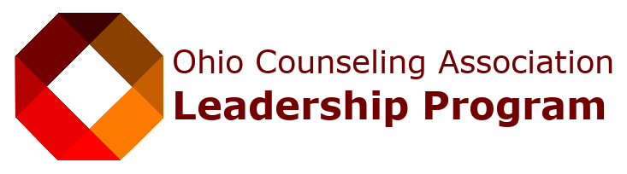

OCA celebrates the inaugural Winter Series group completing the Leadership Certificate Program under
Laura Lewis, Leadership Development Chairperson

Congratulations!

LCP Graduate’s Name | School or Place of Employment
Kathleen Bylewski | University of Akron
Kylena France | Therapist/Private Practice
Amanda Shuluga | John Carroll University & Youngstown State University
Tara Hill | Wright State University
Hope Hornish | Winebrenner Theological Seminary & A Renewed Mind a Division of Ohio Guidestone
Shazia Naurin | Ohio University & The Counseling Source
Courtney Montanye | Capital University
Leah Wood | Heidelberg University
Anne Lange | Capital University
Lauren Baker | Ohio Guidestone
Kathy Caputo | Student John Carroll University
Christine McCrone | University of Akron & Psych & Psych Services
Marie Walker | Heidelberg University
Christina Scott | Ohio University & Rising Action Counseling
Erica D Ogletree | University of Cincinnati & TREEmendous Care
Angel Lacey | Ohio Wesleyan University
Jason Decker | Wake Forest University
Carrie D. George | Heidelberg University & Buckeye Ranch
Richa Bhatia | Ohio University
Kristin Curran | Malone University
Mykka Gabriel | Kent State University
Richa Bhatia | Ohio University

Many thanks to Laura Lewis for developing and running with this idea!

Speaker Photos and Bios
in alpha order/last name

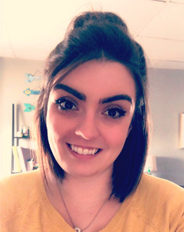 | Kimberlee Barrella, MEd, LPCC-S is Co-Owner and Clinical Director of Navigate Counseling and Consultation Services. In addition, she is a doctoral candidate in the Counselor Education and Supervision program at Kent State University and adjunct instructor at Youngstown State University. Kim’s professional and research interests include motivational interviewing, identity exploration and development among emerging adults, and leadership.
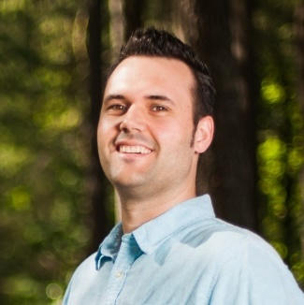 | Daniel Bates, MA, LPC, NCC is a doctoral student at the University of Cincinnati and licensed professional counselor. He has been a working professional in the mental health field for over 13 years and has extensive clinical experience working with male clients in individual, couples and family counseling across different settings.
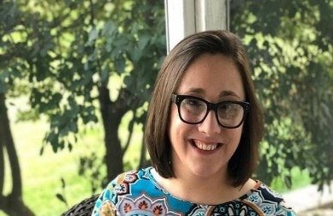 | Kailey Bradley, MA, LPCC-S is a doctoral candidate in Counselor Education and Supervision. She is a Licensed Professional Clinical Counselor in the state of Ohio with supervisory designation as well as a clinical thanatologist credentialed through ADEC (Association of Death Educators and Counselors). Her primary clinical experience has been in hospice care as a bereavement counselor with special expertise in children's bereavement, disenfranchised grief, and chronic illness. Kailey also teaches courses on grief counseling as well as death and dying courses. Kailey's goal through all of her trainings, workshops, and classes is to create a space where the normal plethora of grief is welcome and validated.
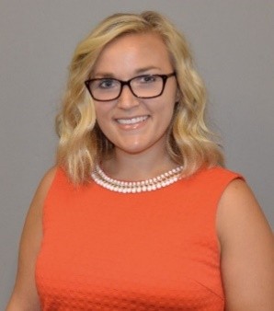 | Kristin Bruns is, Ph.D., LPCC is an Associate Professor in the Counseling Program and serves as the Coordinator of the College Counseling & Student Affairs Counseling Program. She has over 10 years of clinical experience working in various settings including community mental health centers, private practice, and college counseling centers.
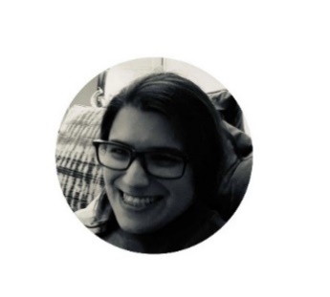 | Kathy Caputo (She, Her, Hers) is a Mental Health Counseling student at John Carroll University. She has a passion for those who are differently abled and those who are recovering from trauma.
 | Kübra Civan, MS has a master’s degree in counseling from Turkey and is currently finishing her second year in the Counselor Education and Supervision doctoral program at Ohio University. She has experience as a school counselor with refugee students and clinical mental health counselors, specifically in addiction. Her current position is as a teaching assistant at Ohio University.
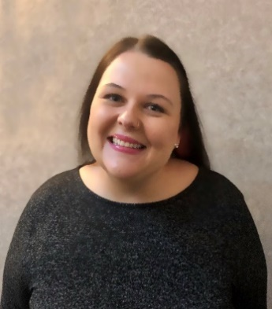 | Amanda Cole, MA, LPCC-S is a second-year doctoral student in Counselor Education and Supervision at Kent State University. She has over 10 years of clinical experience across diverse settings and has been a licensed supervisor for 5 years. She has received approximately 300 hours of training in psychodrama group work from certified psychodramatists, has studied at the National Psychodrama Training Center, and is currently pursuing certification.
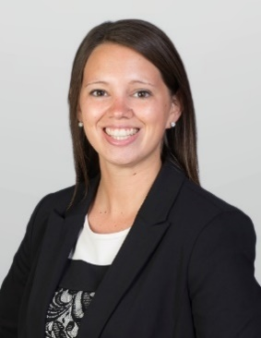 | Meredith Craig was named Assistant Director of Legislative Affairs for the Ohio Department of Insurance in September 2017. Alexander is responsible for the Department’s legislative efforts, including representing the Department on all legislative and policy issues before the Ohio General Assembly. Alexander joined the Department in 2016 as a Legislative Liaison after serving in the Ohio House of Representatives as Senior Legislative Aide to Speaker Pro Tempore Ron Amstutz. Prior to that, Alexander participated in the Ohio Legislative Service Commission Fellowship Program and served in the Ohio Senate.
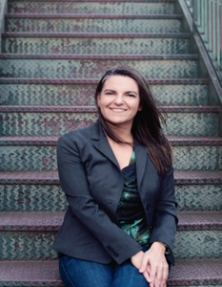 | Jenny Cureton (she/they), PhD, LPC (TX, CO) is an associate professor of Counselor Education and Supervision at Kent State University and President-elect of the Ohio Association for Resiliency and Trauma Counseling (OARTC). She uses her counseling experience in community and medical clinics, college/university settings, and private practices to inform her research and teaching in the areas of crisis and trauma, career development, and community and cultural responsiveness.
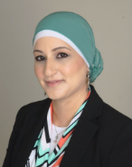 | Tahani Dari, LPC, NCC is an assistant professor of counselor education at the School of Intervention and Wellness at the University of Toledo, Ohio. Her scholarly work has focused attention on conducting community-based participatory research, with areas of interest on working with and advocating for diverse client populations (particularly youth) and advancing topics in school counseling. Dr. Dari’s research is shaped by her experiences as a counselor and community-based research partner. Dr. Dari prioritizes community partnerships in her research, and her work provides a model for constructing collaborative and culturally sensitive research programs with diverse populations. She has presented her work regionally and nationally and is published in counseling journals. Over two decades of experience inform Dr. Dari’s commitment to serving diverse and underserved communities. She has served as a school counselor for K–12 students and a mental health counselor in various settings
 | Anna Ellenson, M.S. LPC (she/her) is a doctoral student in Kent State University's Counselor Education and Supervision program. She is also a licensed counselor in the state of Ohio."
 | Aaron Ellington, Ph.D., LPCC-S, LICDC-CS is one of the founders and owners of Behavioral Health Services of Greater Cleveland. His doctorate and master’s degree are in counseling psychology from Cleveland State University and University of Wisconsin at Madison respectively. He is licensed in the state of Ohio in Psychology, Counseling, and Chemical Dependency. He is a Diplomate in Cognitive Behavioral Therapy from The Academy of Cognitive Therapy. Nevertheless, he is well trained in Dialectical Behavioral Therapy and Motivational Interviewing as well. He is well versed in running groups, individual counseling, assessments (psychosocial, chemical dependency, and some psychological testing), training seminars, research, crisis intervention, and case management.
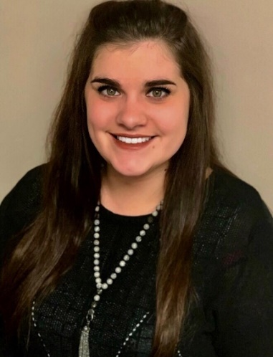 | Annaleise Fisher, LPC is a doctoral candidate in Counselor Education and Supervision. She is a Licensed Professional Counselor in the state of Ohio. She has experience teaching undergraduate and graduate level addictions counseling courses. She has over 300 hours of training in motivational interviewing and is a Level 1 MITI Certified Coach. She has provided numerous professional motivational interviewing trainings to a variety of helping professions around northeast Ohio.
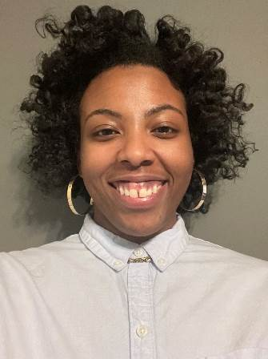 | Christin Fontes is a student at Malone University studying clinical mental health counseling. She is the secretary for the Mu Alpha Omega chapter of Chi Sigma Iota and an Emerging Leader for the Eastern Ohio Counseling Association.
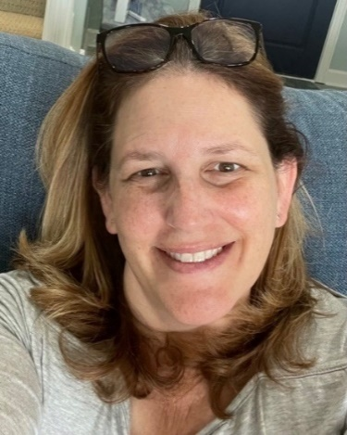 | Susan Fox is a graduate student at John Carroll University studying school counseling. She is an Intervention Specialist for Ashtabula Lakeside Junior High School's behavioral intervention classroom, a member of the Beta Chi chapter of Chi Sigma Iota, as well as a wife to an amazing husband and a mother of two wonderful children. After receiving her son's diagnosis of Autism and ADHD at age 5, she earned her master’s certificate in special education - Autism at George Mason University, where she was awarded the Graduate School of Education Outstanding Student in Special Education Award – Autism. In addition to attending graduate school, teaching, and being a full-time mother and wife, Susan provides assistance in navigating the world of neurodiversity to parents of children with neuro differences in Ashtabula County.
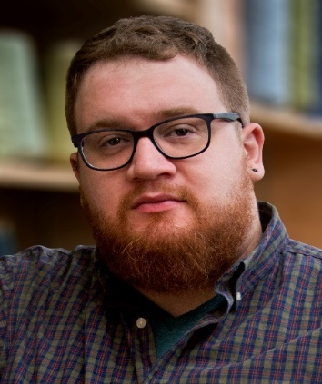 | Trey Gehring is a master’s student in Kent State’s Clinical Mental Health Counseling program, planning to specialize in work with LGBTQIA+ clients. From the onset of his master’s work, Gehring has augmented his academic program with specialized training in Acceptance and Commitment Therapy and is passionate about this flexible and effective model.
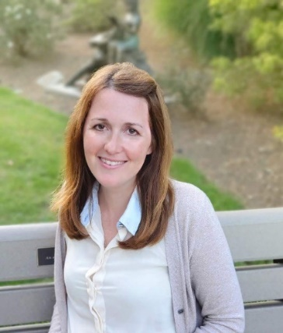 | Alicia Hall (she/her), M.A., LPCC-S, is a clinical counselor for youth, adults, and families and specializes in trauma-informed and resiliency practices. She serves as President of the Ohio Association for Resiliency and Trauma Counseling (OARTC). She also teaches as adjunct faculty and frequently presents and advocates locally, state-wide, and nationally on resiliency and trauma counseling.
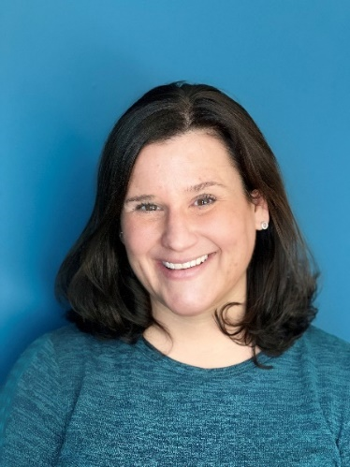 | Staci Hayes, PhD, LPCC received her Ph.D. in Counseling Education and Supervision in 2019 from Kent State University where she was honored with being awarded the Outstanding Adjunct Faculty Award. As a Faculty member at John Carroll University, she has a continued commitment to challenge students and create enthusiasm and joy for the profession she is passionate about. Dr. Hayes enjoys her work with both the Emerging Leaders and Awards committee of AHC. Most recently, she has assembled a research team of students and colleagues to investigate and explore mental health and wellness in the Metaverse. She plans on starting a non-profit focused on this area and continuing education and academic conversation in this realm.
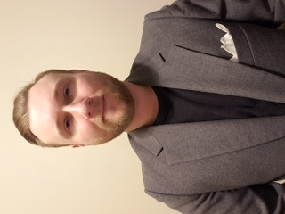 | Andrew Herbell, LPC / NCC is a doctoral candidate in Counselor Education and Supervision at Kent State University. He is a Licensed Professional Counselor in the state of Ohio and National Certified Counselor. He has experience teaching motivational interviewing consistent coursework and has over 100 hours of training in MI. He is also adjunct faculty at Cleveland State University and a consultant and continuing education provider at Navigate Counseling and Consultation.
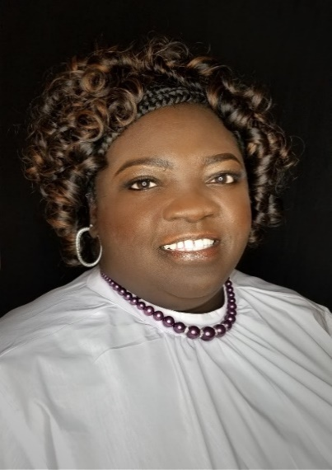 | Carmella Hill, M.Ed., P.C.C-S is the Director of Behavioral Health at Coleman Health Services (CHS) in Trumbull County. She has worked within the mental health profession for over 20 years serving the entire lifespan in various settings (e.g., community mental health agencies, nursing homes, private practice). Carmella enjoys clinical work, professional development, and supervising persons for licensure. She is a sought-after speaker for cultural diversity issues. She is often invited to conduct workshops and seminars on the topic for agencies, groups/teams, and organizations. She is passionate about helping professionals develop an awareness and sensitivity to multicultural issues. Carmella teaches, conducts workshops, and speaks at various conferences on other topics related to mental health, treatment, and documentation, to name a few. She has taught within higher education at the undergraduate and graduate levels. In addition to her role at Coleman, she is an adjunct faculty member at Cleveland State University and Youngstown State University.
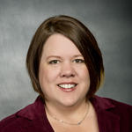 | Terra Hill, PhD, LPCC/S is an Associate Professor at Wright State University. She started her career working at a community mental health agency and enjoys providing clinical supervision to new counseling professionals.
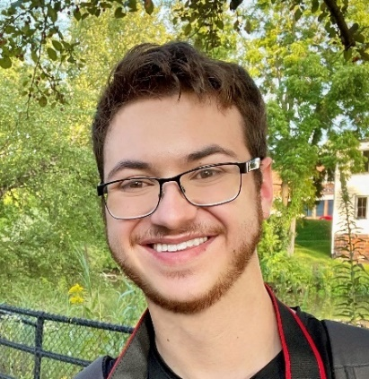 | James Hoag, CT is a graduate student in the Clinical Mental Health Counseling program at John Carroll University.
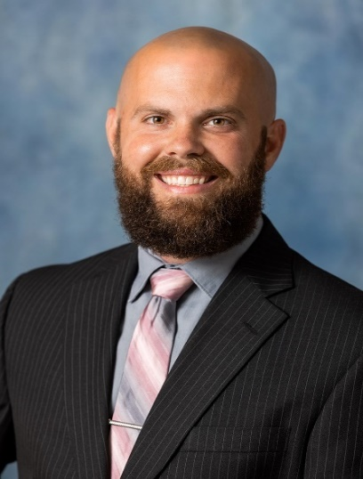 | Brad Imhoff, PhD., LPC earned a Ph.D. in Counselor Education & Supervision from Ohio University. He currently serves as the Director of the MA in Addiction Counseling program for Liberty University Online and is Core Faculty in their CACREP-accredited CMHC program.
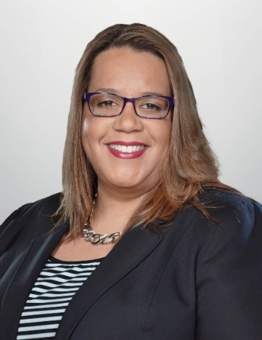 | Jana Jarrett was named the Ohio Department of Insurance’s Assistant Director of Consumer Affairs in April 2010 and oversees the Consumer Services Division as it assists consumers on the phone, through Internet communications, written correspondence and in one-on-one meetings. Other activities of the division include meeting insurance industry professionals and managing the Missing Life Policy Search program.  Jarrett joined the Department in 2001 as an Insurance Complaint Analyst with the Consumer Affairs Division, where she served for five years before moving into the Enforcement Division. In that capacity, Jarrett held the position of Insurance Investigative Officer prior to taking on the role of Investigations Supervisor in 2008.  Jarrett worked in the insurance industry for five years before coming to the Department.
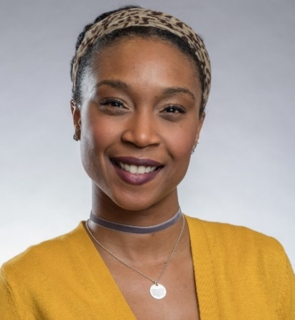 | Kalesha Jenkins, PhD, LPC, NCC is a graduate of the University of Cincinnati in Counselor Education and Supervision. She received her master’s in mental health counseling from the University of Cincinnati and bachelor’s in psychology and business from Seton Hill University. Her research focuses on the self-awareness process and the influence of privilege and marginalization in multicultural competency and development through community-based practices and multicultural methodologies. Dr. Jenkins is a teaching professor at Antioch University New England and licensed professional counselor working with adults in underserved communities that suffer from race-based, historical, and generational trauma using psychodynamic and postmodern psychotherapy. She serves on various national boards and committees including the current President for the Greater Cincinnati Counseling Association.
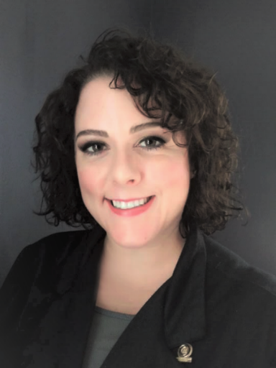 | Adrianne Johnson, Ph.D., LPCC-S is a private practitioner and an Associate Professor in the Clinical Mental Health Counseling program at Wright State University in Dayton, Ohio. She is a member of the Ohio Behavioral Health Providers for Insurance Advocacy coalition and the OCA Insurance Advocacy Committee.
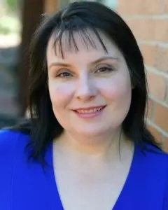 | Yvonne Judge, MFT, CHt is a Marriage and Family Therapist and Certified Clinical Hypnotherapist in Upper Arlington, Ohio. She specializes in couples, trauma and hypnotherapy and is currently pursuing her PhD in Marriage and Family Therapy.
Megan Mahon, Ph.D, LPCC/S is currently Core Faculty at Capella University. She earned her B.A. at the University of Michigan (Go Blue), M.A. in Mental Health Counseling at Heidelberg University, and her Ph.D. in Counselor Education at The University of Toledo.

Over her career, Dr. Mahon has served the counseling profession in a variety of capacities, most notably as a board member of the Northwest Ohio Counseling Association (NWOCA), Ohio Association for Counselor Education and Supervision (OACES), and the Society for Sexual, Affectional, Intersex, and Gender Expansive Identities of Ohio (SAIGEO). She has also presented at local, state, and national conferences, and published in peer-reviewed journals.
Prior to teaching, Dr. Mahon worked in a variety of settings including community mental health, drug rehabilitation, college counseling, and private practice. In her current teaching position, Dr. Mahon enjoys assisting graduate students in achieving their dreams!
 | Jeff Mazzone is a 2021 graduate in clinical mental health counseling from Liberty University, and a resident in counseling at a private practice in Stafford, VA.
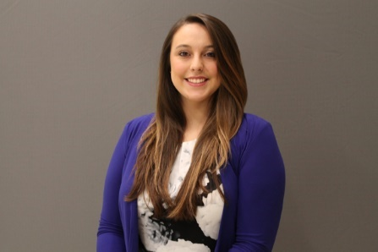 | Stephanie Maccombs-Hunter, PhD, LPCC-S, LICDC, CRC holds a Doctor of Philosophy degree in Counselor Education and Supervision from Ohio University, is licensed in the state of Ohio as a Licensed Professional Clinical Counselor with training supervision designation and a Licensed Independent Chemical Dependency Counselor, and is a nationally Certified Rehabilitation Counselor. She currently works as a staff counselor at Ohio University’s Counseling and Psychological Services, and previously worked in a federally qualified health center with adults participating in medication assisted treatment and local drug court programs. Dr. Maccombs-Hunter additionally teaches at the master and doctoral level as an adjunct instructor at Ohio University and The Family Institute at Northwestern University, is engaged in leadership as President of the Southeast Ohio Counseling Association, and has presented on a variety of topics at the state and national level, including on the topic of ethical practice and telehealth.
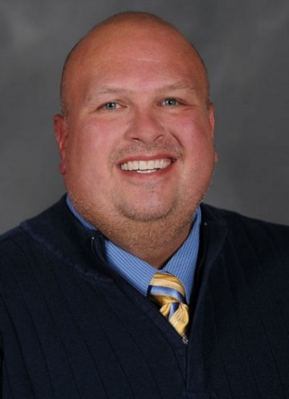 | Jason McGlothlin, PhD, LPCC-S has a lengthy career as a counselor. He earned his master’s degree from the University of Dayton in Community Counseling and his doctoral degree in Counselor Education and Supervision from the Ohio University. For over twenty-five years, he has focused his practice, teaching, and research in the area of suicide prevention, assessment, and treatment. Currently he is an Associate Professor in the Counselor Education and Supervision program at Kent State University. He also has a small private practice where he specifically works with suicidal individuals and consults with agencies, hospitals, and schools and effective suicide assessment and treatment practices. He is currently the President of the Ohio Counseling Association.
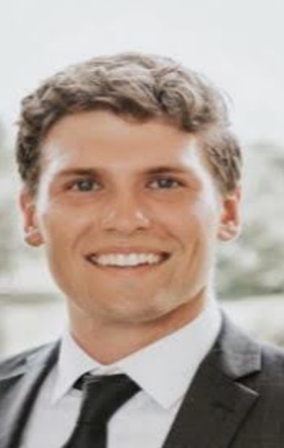 | Sean McKinney, CT is a graduate student at John Carroll University in the Clinical Mental Health Counseling program. He is currently completing his practicum at Moore Counseling and Mediation.
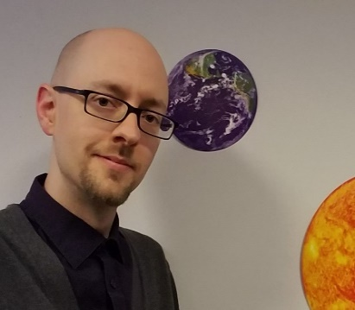 | Andy Miller serves as Compliance Officer for the Ohio Counselor, Social Worker, and Marriage and Family Therapy Board. He’s worked for the Board since 2011 in various capacities, but his most recent work focuses on ethics, investigative complaints, and disciplinary actions taken by the Board.
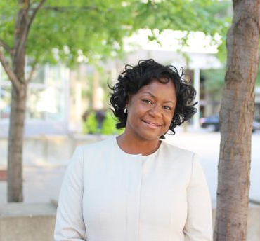 | Martina Moore, Ph.D., LPCC-S, LICDC-CS, CEAP, SAP is on faculty at John Carroll University, were she serves as the Coordinator of the Substance Use Disorder Concentration in the Clinical Mental Health Program. She is the President and CEO of Moore Counseling & Mediation Services, Inc., (MCMS). This organization has several outpatient alcohol and drug treatment centers in Northeast Ohio. Dr. Moore’s areas of research include dual diagnosis population, medication-assisted treatment for opiate use disorders and trauma-informed treatment for human trafficking survivors.
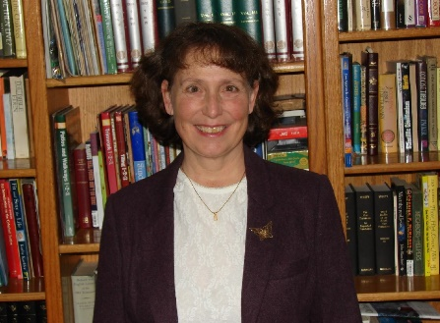 | Cherry Nelson, LPCC-S works as a mental health counselor in the state of Ohio and is a CES doctoral student at Liberty University. Her interests include animal assisted therapies and treating military populations. She is Equine Assisted Growth and Learning Association (EAGALA) certified.
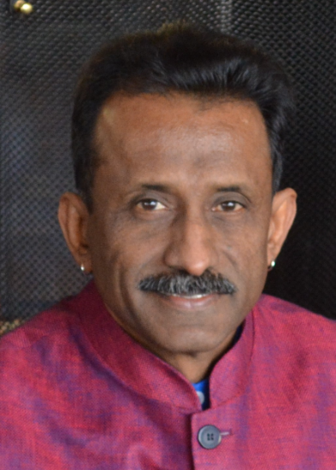 | Yegan Pillay, PhD, LPCC-S is a clinical mental health counselor with supervisory endorsement and a counselor educator with over 25 years of experience in the mental health field. He is currently a full professor and a core faculty member at Ohio University and has held various leadership positions at the state, national and international levels. He teaches a variety of graduate courses that prepare students at the master's level in the school, clinical mental health and the clinical rehabilitation counseling specialties and in the doctoral Counselor Education and Supervision program. His scholarship includes publications in refereed journals and refereed presentations at state, national and international conferences.
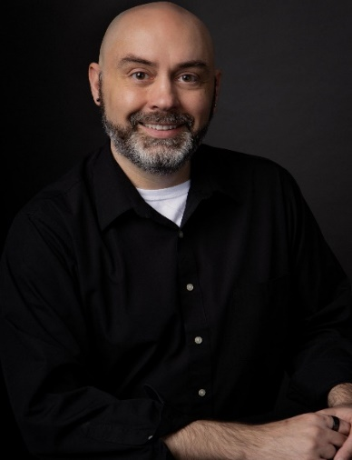 | Jared Rose, PhD, LPCC-S, NCC, EMDRC is an Assistant Professor and the Program Coordinator for Bowling Green State University’s Clinical Mental Health & School Counseling Programs and owner of a private practice. In public health and clinical mental health arenas, he has over 30 years of experience as a helping professional. His areas of clinical practice, research, and teaching include LGBQ+ and Trans/Gender Expansive; human trafficking; HIV and AIDS; and advocacy & social justice in the counseling profession.
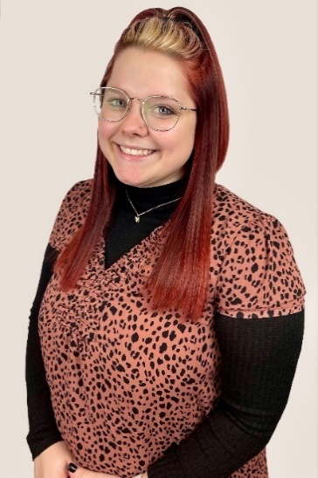 | Hannah Rowe, BA, CT is a clinical mental health counseling graduate student at Bowling Green State University. She will complete her program later this summer. Hannah is a Therapeutic Behavioral Service provider at Children's Resource Center, where she provides provide direct care to youth in Wood County with emotional and behavioral difficulties. Hannah is also a counseling intern with the University of Toledo’s Counseling Center. Her future clinical work will include a keen focus in working with LGBQ+ and Trans/Gender Expansive folx.
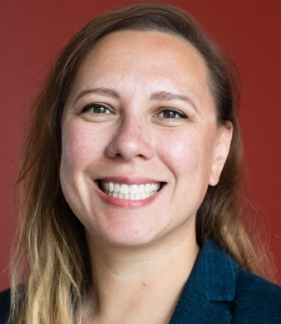 | Michelle Sammons-Ingrisano, M.Ed., LPC is a doctoral student in Counselor Education & Supervision at Kent State University and received her Master’s degree in Clinical Mental Health Counseling from Cleveland State University.
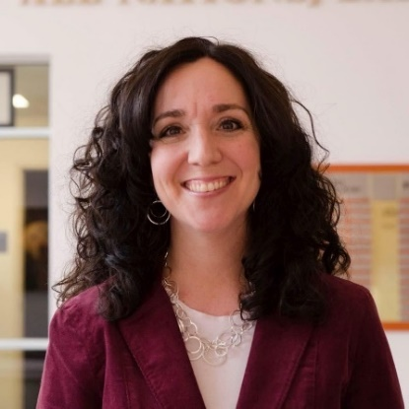 | Christina Schnyders, Ph.D., LPCC-S is an Associate Professor of Counseling and Human Development and serves as the Director of Graduate Counseling Programs at Malone University. She has extensive experience counseling in community mental health, college counseling, and private practice settings. Her research interests include clinical termination, clinical supervision, and emerging adult counseling.
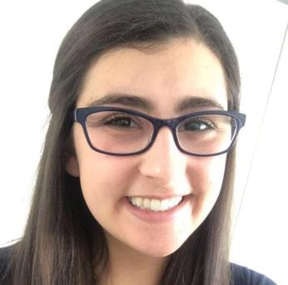 | Amanda Shuluga, MA, LPC is a Licensed Professional Counselor in the state of Ohio. She currently works as an adjunct instructor in the Counseling Department at John Carroll University.
 | Sherdene Simpson, Ph.D, LPCC-S, LMFT, CHT is a Visiting Assistant Professor of Counselor Education at Cleveland State University. She is a Licensed Professional Clinical Counselor, with Supervisory designation (LPCC-S), Licensed Marriage and Family Therapist (LMFT), Certified Clinical Hypnotherapist (CHT), and Certified in Grief Recovery Methods with experience in community and private practice settings. Her clinical interest include incorporating systemic therapy to individuals, couples, and families. Her research interest include systemic treatment, marriage and family therapy, clinical supervision, multiculturally informed clinical supervision, and isomorphism in clinical supervision. She is a certified trainer for PREPARE/ENRICH Inventory and is currently completing training for the Gottman Institute Certification program.
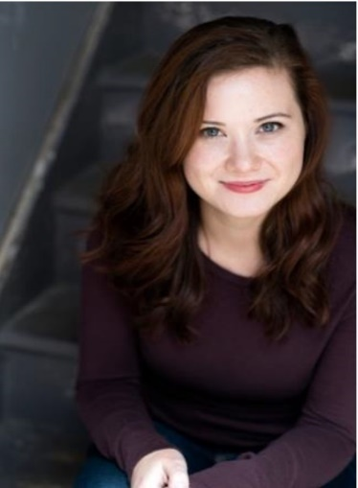 | Kelly Smith is a current graduate student at John Carroll University in the Clinical Mental Health Counseling program.
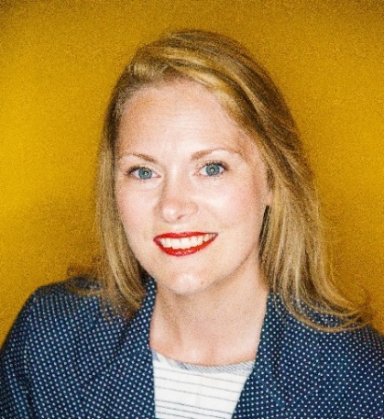 | Patricia Stewart-Hawkins, Ed.D, LPCC-S has practiced as a counselor for 15 years. Her work in community mental health agencies was coupled with adjunct teaching for over a decade. She is teaching and supervising students at the extended campus of Lindsey Wilson College in Hillsboro, Ohio.
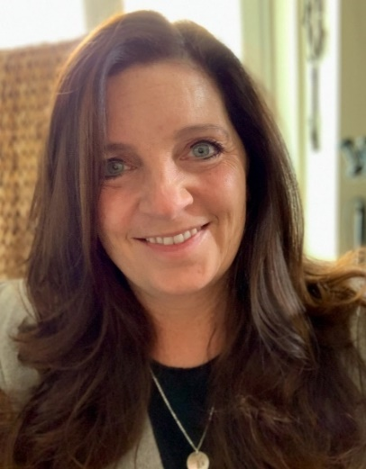 | Debbie Sturm, PhD, LPC is a Licensed Professional Counselor and Professor at James Madison University in the Shenandoah Valley of Virginia. Her clinical specialties include trauma, community violence, family systems, nature-connectedness, leadership & advocacy, and climate change & mental health. She has graduate coursework, training, and teaching in environmental advocacy, environmental education, climate resilience efforts, environmental justice, and communication strategies. She is a member of ACA’s Climate Crisis Task Force and the current Chair of the ACA Human Rights Committee.
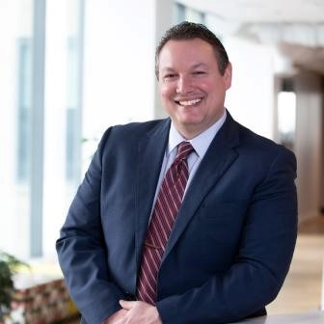 | Robert Switala graduates this May in clinical mental health counseling from Liberty University, and will be continuing at a private practice in Endicott, NY.
 | Shantel Thomas, Ph. D. PCC-S, LSW is President and CEO of A Sound Mind Counseling Service, LLC. She received her B.A., M. Ed. from the University of Toledo where she attended on a full athletic scholarship and had a stellar career as a sprinter, traveling the world competing and receiving various honors, including MAC Athlete of the Year and NCAA Woman of the Year for Ohio. Her doctorate is from Kent State University. Thomas was inducted into the University of Toledo’s Hall of Fame and selected as one of Cincinnati’s Leading Women. She was a Health Care Hero and Athena Awards finalist in 2006. She was also honored in Who’s Who of Black Cincinnati in 2009 and 2007. She is a member of Alpha Kappa Alpha Sorority, Inc. and a life member of the Ohio Counseling Association.
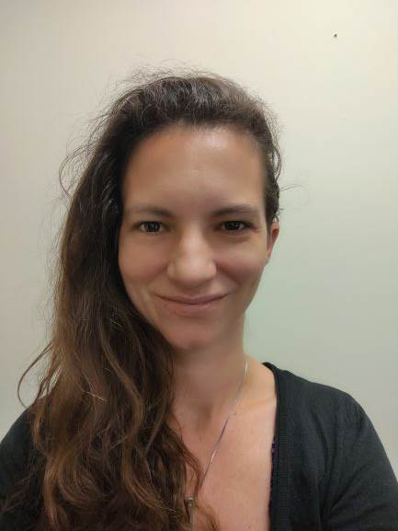 | Natalie Thornberry, Ph.D., LPC is an assistant professor at Malone University. She is a licensed professional counselor and currently pursuing a professional school counseling license. She has presented at the local, state, and national level on topics related to ethics, counseling minors, parenting, and trauma counseling. She is involved in national and state professional groups, serving as treasurer for Eastern Ohio Counseling Association and the president elect of Ohio College Counseling Association.
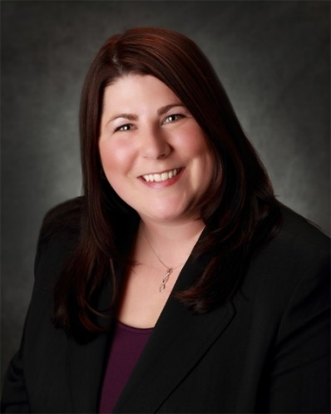 | Carrie VanMeter, Ph.D., LPCC, LSC is a core faculty member at Capella University. She earned her Master's degree in Community Counseling from Heidelberg University and her Ph.D. in Counselor Education and Supervision and School Counseling Certificate from The University of Toledo. She is a licensed Professional Clinical Counselor (LPCC) and a licensed Professional School Counselor (LSC) in the state of Ohio. She has experience working with children both in the community and the high school setting. She also has experience in community mental health agencies providing treatment for juvenile sex offenders, sexual abuse survivors, domestic violence perpetrators and survivors. She is involved in numerous professional organizations including ACA, ASCA, ACES, OCA, OASCA, OASGW, and ASGW. Her research interests include teen dating violence, domestic violence, offender treatment, supervision in counseling, and professional identity and advocacy in counseling.
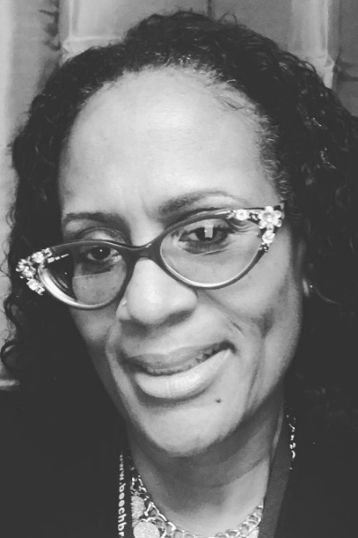 | Genice Williams-Rivers, PhD, CES is the Founder and CEO of I Matter Counseling & Empowerment Services, inc. (IMCES) located in Cleveland, OH. IMCES is a nonprofit private practice serving primarily Children and Families affected by complex trauma.  Genice is a Licensed Professional Clinical Counselor with a Supervisor designation completing her Doctorate degree in Counselor Education and Supervision at Walden University.
 | Christina Woloch, Ph.D., LPC, LICDC holds a Ph.D. in a Counselor Education/Supervision and displays a deep commitment for social equality, justice, and health/wellness in her roles as a Licensed Professional Counselor, a Licensed Independent Chemical Dependency Counselor, and an Assistant Professor at a Malone University. She has presented at the local, state, and national level on a variety of counseling topics pertaining to counselor pedagogy, professional ethics, addictions, skills/best practices, and multicultural/social justice/diversity issues. She is also a published author and research enthusiast. In addition to her involvement in numerous state and national counseling committees/associations/groups, she has been recognized by the following awards: OCA - Graduate Student of the Year, AHC- Emerging Leader, OCA - Emerging Leader, and Chi Sigma Iota - chapter awards.

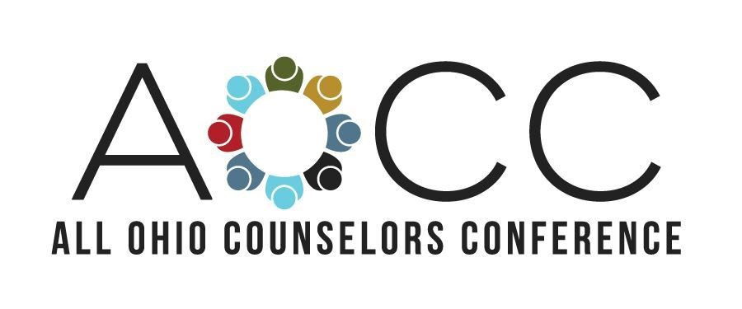

Save the Date for the
2022 All Ohio Counselors Conference (AOCC)
October 17-19 at the Hyatt Regency in Downtown Columbus

Call for Proposals is now open through May 16!
Visit www.aocc.site/cfp to begin your proposal!

Join, Renew, or Upgrade today at www.OhioCounseling.org

